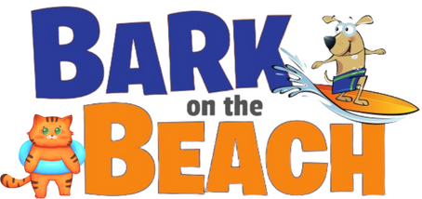

Here’s a sample email template for you to send to supporters:
Dear Friends:
I’m excited to be taking part in Animal Rescue Rhode Island’s (ARRI) 12th Annual Bark on the Beach fundraiser and walk on September 23rd.
I hope you’ll join me with a donation to help give homeless animals a second chance. Please follow this link to my Fundraising page:
INSERT LINK HERE
Any amount will be deeply appreciated.
ARRI has been serving the Rhode Island community for 85 years! Along with placing hundreds of pets in loving homes each year, they have amazing, free programs, such as their Community Pet Food Pantry and humane education classes.
All funding raised for ARRI goes directly to rescuing and caring for homeless animals. They receive no local, state, or federal funding, so your donation is critical for their lifesaving work.
Thanks for your kindness and for helping me to raise vital funds for the animals at ARRI!
Best,
Your Name

